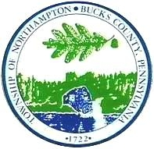
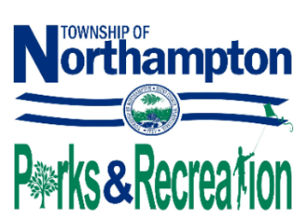
Northampton Township

Park & Recreation Board Meeting

Meeting Agenda

January 8, 2026
7:30 PM

Call to Order

Roll Call of Board Members

Approval of Minutes
Reorganization/Reappointment of Board Members
Citizen Concerns

Old Business
- Progress on Field Clean Up at Civic Center
- Winterization Reminder for 2026
- St. Leonard’s Facility Repairs

New Business
- Field Requests Due by Dec. 31, 2025
- Accreditation Docs by Jan. 31, 2026
- NTPR Festivals 6/5/26 and 12/4/26 – Sports Groups Affected
- Northampton Day – October 4, 2026
- Approval of 2026 Meeting Dates
- Appointments to Wall of Honor Committee
(Board and Youth Sports Reps)

Field Users Reports
- Council Rock Basketball
- CR Holland/Northampton Baseball
- Council Rock United Soccer
- Northampton Girls Softball
- Northampton Indians Football

Parks & Recreation Director Report

Supervisor Liaison Report

Citizen Concerns

Announcements

Adjournment

WORKSHOP: The Northampton Township Park and Recreation Board will meet at 7:00 pm to review agenda

